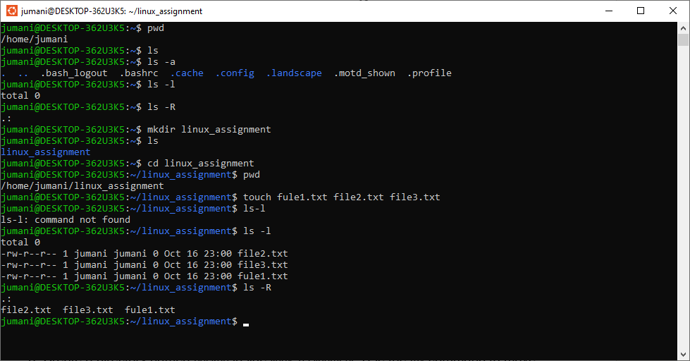

First 5 commands along with their verification.

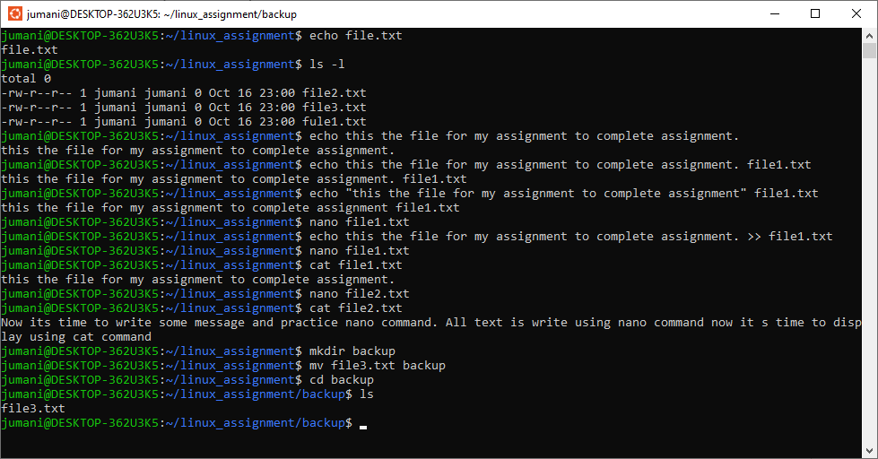

Display shows Question 6, 7 and 8 Answers.

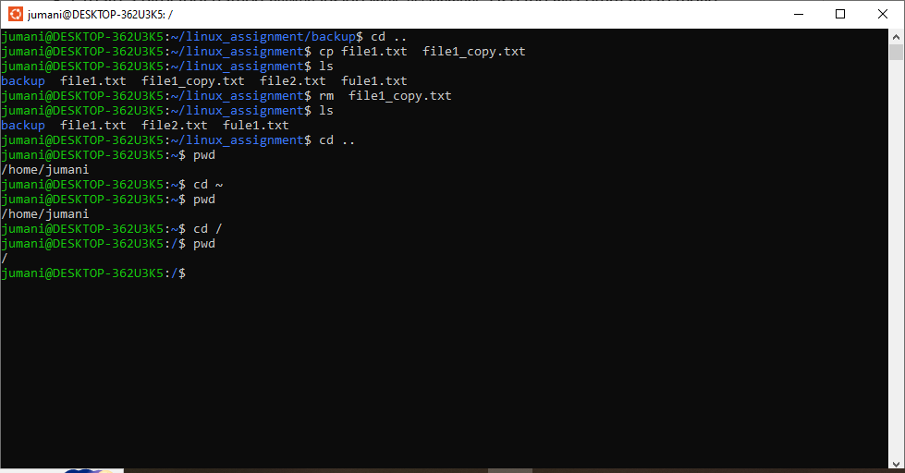

Two command CP and cd practice

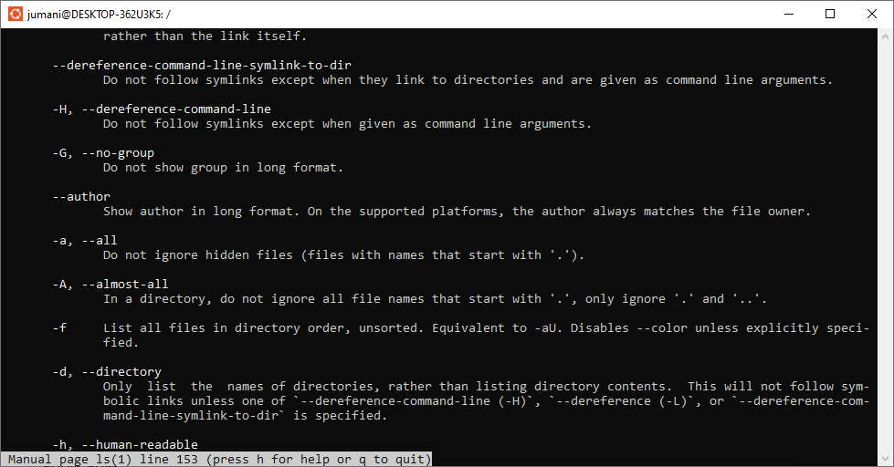

The file or folder which are hidden can list with ls -a.
If you want to create a file or folder to hide it linux then use . as first character in name of file or folder.

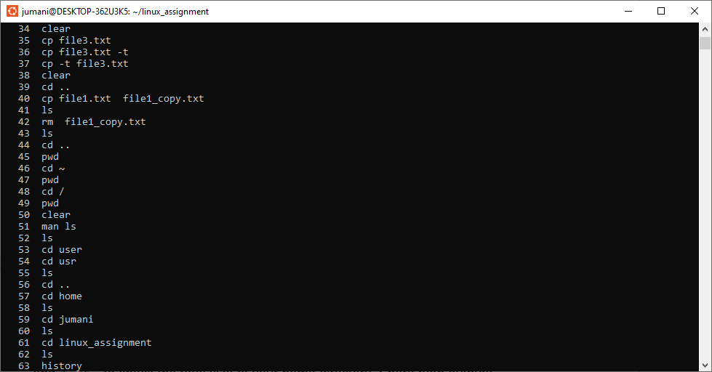

History command

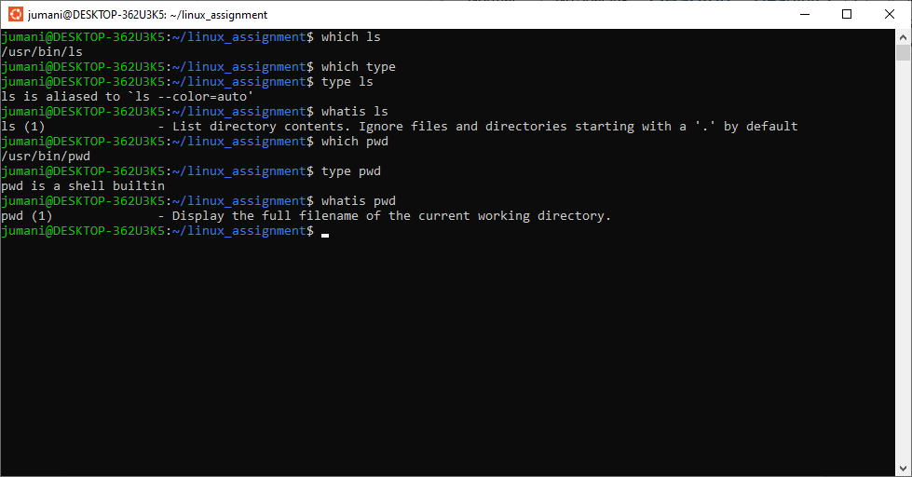

Which, type and whatis on both pwd and ls command.

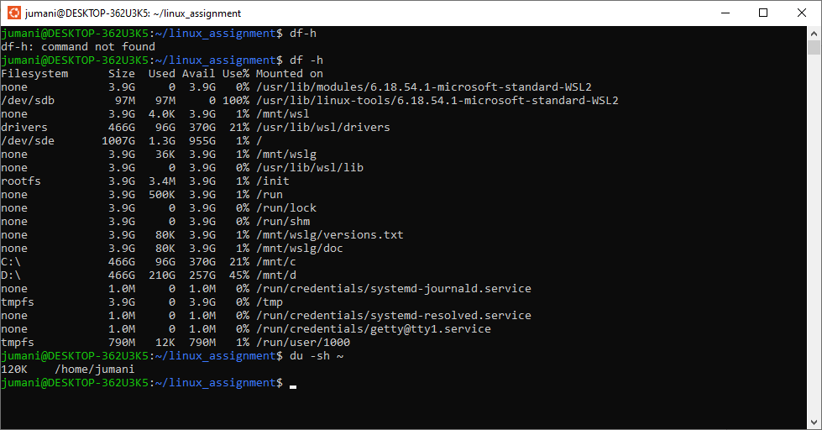
Practice of du and df commands along with their respective basic flags

